Instructions to Sign up for Participant Research Points

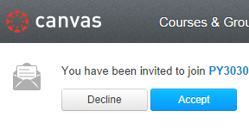
- You will receive an email inviting you to enroll in a course called PY3030Z (this course may not be available until it has been published by the administrator). Login in to Canvas and click accept.

- Then click Yes to confirm who you are.

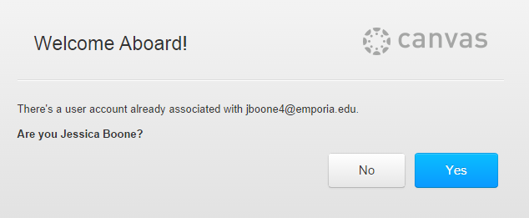

- Under Courses & Groups you will see a link called PY3030Z. Click PY3030Z

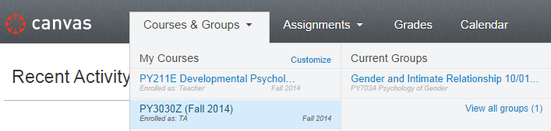

- The experiments that have been posted will be shown. To view the details of an experiment, click on the name of the experiment which is “Psychology of Attraction” in this instance.

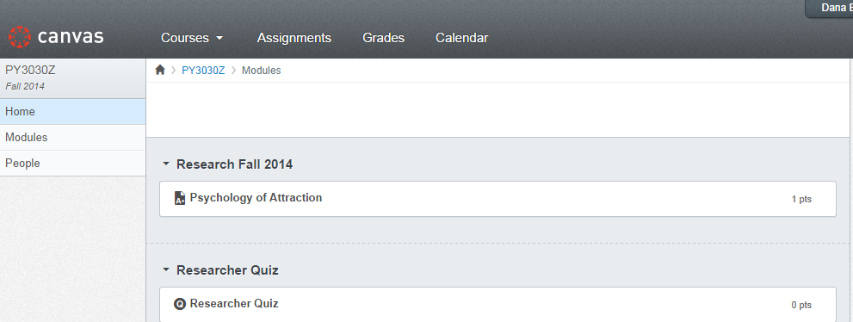

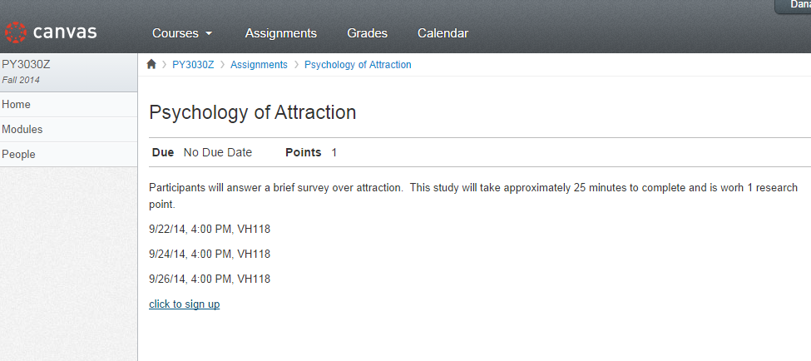
- This is where you will find important experiment information such as the date, time, and location of the experiment. You will be responsible for knowing when and where the study is taking place so you will need to write down this information. In order to sign-up for a study click, the “click to sign up” button and your name will then appear on the list below.

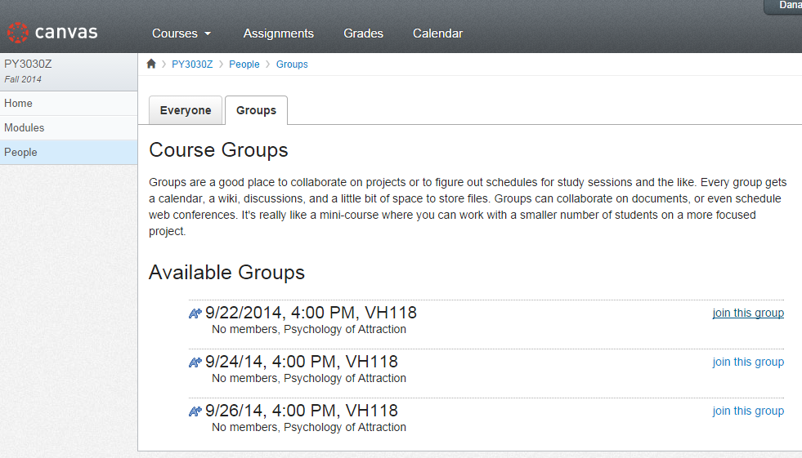
- Click “join this group” next to the section that works with schedule.

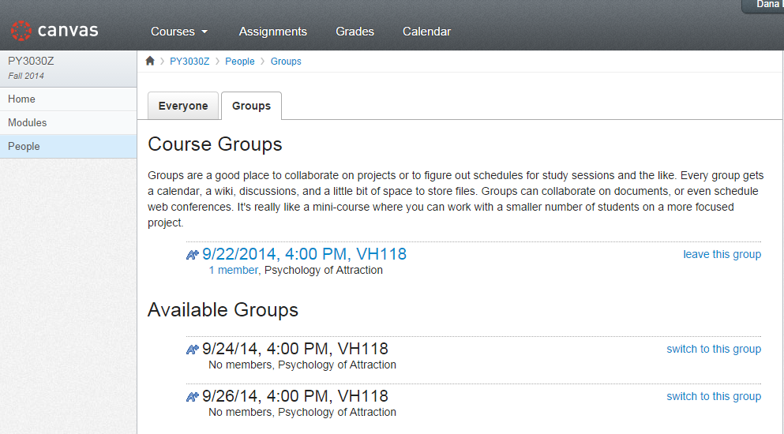
- If you sign up for an experiment and realize you cannot make it to the experiment for any reason, simply return to the experiment you signed up for and you can withdraw by clicking the “leave this group” button without penalty up to 30 minutes before the start time of the experiment.
If you signed up for an experiment and do not show up AND you have not withdrawn from the study the appropriate number of research points will be deducted and you will need to make up for the points you skipped to complete your course requirements.

ONLY SIGN UP AND ATTEND ONE SESSION FOR EACH STUDY

